Monday’s Marvelous Animal (MMA) Name__________________

Spotlight: _______________ Home Range: (Color in map)

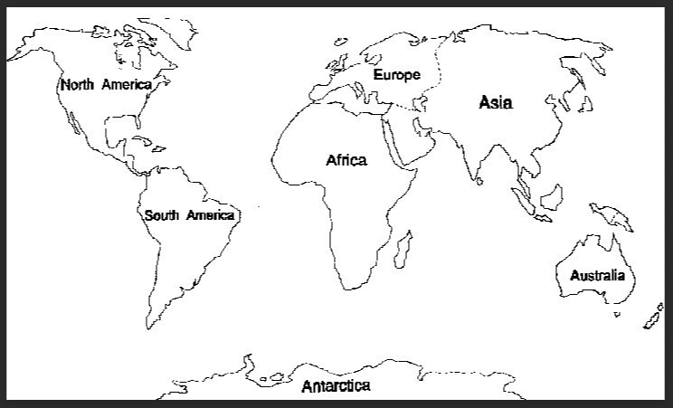Classification: (KPCOFGs)

* K = ________________
* P = ________________
* C = ________________
* O = ________________
* F = ________________
* G = ________________
* s = ________________

Natural Habitat/ Housing Needs: (#/sq. ft. OR acre)

Historical Uses: ________________________________________________________________________________________

Use today: ____________________________________________________________________________________________

Rating: (Endangered, Extinct, Flourishing, Invasive, Threatened, or Special Concern) - Circle best fit!

Closest related Species/ Kinds: ___________________________________________________________________________

Nutritional Needs/ Diet: (Include h2o)

Normal Behavior:

Age of Sexual maturity: _______________ (males) _______________ (females)

# of offspring: _______________ (at each parturition) Gestation Length: _______________

Health Concerns/ Issues:

|  |  |
| --- | --- |
|  |  |
|  |  |
|  |  |
|  |  |
|  |  |

Other Facts Grade: _________